SOFTWARE REQUIREMENT SPECIFICATION DOCUMENT
Employee Management System
SOFTWARE CONSTRUCTION AND DEVELOPMENT
Submitted By | Rimsha Ejaz
Title | SCD Lab and Theory Project
Group Members | Eshal(232033)(A) , Rimsha (232045)(A), Fasiullah (233138)(B)
Submitted To | Sir Sharif Hussain

Chapter 1: System Requirements and Design (SRS & UML)
Introduction

Purpose
This Software Requirements Specification (SRS) document defines the functional and non-functional requirements of the Employee Management System (EMS).
The purpose of this document is to provide a clear and detailed description of system behavior, constraints, and performance expectations for development, testing, deployment, and academic evaluation.

Document Conventions
- Shall: Mandatory requirement
- Should: Recommended feature
- May: Optional feature
This document follows the IEEE 29148 Software Requirements Specification Standard.

Intended Audience
- Project Supervisor
- Software Engineering Faculty
- Developers
- Testers
- System Administrators

Product Scope
The Employee Management System (EMS) is a Java-based web application that automates employee data management, attendance tracking, leave processing, and departmental organization.
The system is integrated with a Jenkins CI/CD pipeline for automated build, testing, and deployment on an Apache Tomcat server.

References
- IEEE 29148 – Software Requirements Specification
- Java Servlet API Documentation
- Apache Tomcat Documentation
- Jenkins CI/CD Documentation

Overall Description

Product Perspective
EMS is a standalone web-based application developed using the MVC architecture:
- Model: Java classes and MySQL database
- View: JSP (Java Server Pages)
- Controller: Java Servlets
The system is continuously integrated and deployed using Jenkins, ensuring reliable and automated releases.

Product Functions
The system provides the following core functionalities:
- Secure user authentication
- Employee CRUD operations
- Department management
- Attendance tracking
- Leave request and approval workflow
- Role-based dashboards
- ID card generation
- Automated build and deployment via Jenkins

User Classes and Characteristics
User Type | Characteristics
Administrator | Technical knowledge, full system privileges
Employee | Basic computer skills, limited access

Operating Environment
- Operating System: Windows
- Server: Apache Tomcat 9+
- Programming Language: Java (JDK 17)
- Database: MySQL
- Browser: Chrome
- CI/CD Tool: Jenkins

Design and Implementation Constraints
- Java Servlet–JSP architecture
- Relational database (MySQL)
- Deployment through Jenkins pipeline
- Web-based access only

User Documentation
- User manual for employees and administrators
- Online help pages within the application

Assumptions and Dependencies
- Stable internet connection
- Jenkins server properly configured
- Database availability
- Apache Tomcat configured on deployment server

System Features

Authentication Feature
Description: Secure login and session handling.
- FR-1: The system shall authenticate users using username and password.
- FR-2: The system shall validate user roles (Admin/Employee).
- FR-3: The system shall manage secure sessions.
- FR-4: The system shall allow users to log out securely.

Employee Management Feature
- FR-5: Admin shall add employee records.
- FR-6: Admin shall update employee records.
- FR-7: Admin shall delete employee records.
- FR-8: Admin shall view all employee details.

Department Management Feature
- FR-9: Admin shall create departments.
- FR-10: Admin shall update department details.
- FR-11: Admin shall assign employees to departments.

Attendance Management Feature
- FR-12: System shall record daily attendance.
- FR-13: Admin shall view attendance reports.
- FR-14: Employee shall view personal attendance.

Leave Management Feature
- FR-15: Employee shall submit leave requests.
- FR-16: Admin shall approve or reject leave requests.
- FR-17: System shall maintain leave history.

Dashboard Feature
- FR-18: Admin dashboard shall display system statistics.
- FR-19: Employee dashboard shall display personal information.

ID Card Feature
- FR-20: System shall generate employee ID cards.
- FR-21: Employee shall download ID cards.

CI/CD Deployment Feature (Jenkins)
- FR-22: Jenkins shall automatically build the project on code commit.
- FR-23: Jenkins shall execute automated tests.
- FR-24: Jenkins shall deploy the application to Tomcat upon successful build.

External Interface Requirements

User Interfaces
- Web-based graphical user interface using JSP
- Forms, tables, and dashboards

Hardware Interfaces
- Server machine hosting Jenkins and Apache Tomcat

Software Interfaces
- MySQL Database
- JDBC
- Java APIs
- Jenkins plugins

Communication Interfaces
- HTTP / HTTPS

Non-Functional Requirements

Performance
- NFR-1: System shall support multiple concurrent users.
- NFR-2: Response time shall be less than 3 seconds.

Security
- NFR-3: Passwords shall be encrypted.
- NFR-4: Unauthorized access shall be prevented.

Reliability
- NFR-5: System shall maintain data integrity.
- NFR-6: System shall recover from failures.

Usability
- NFR-7: System shall be user-friendly.

Maintainability
- NFR-8: System shall follow modular design.
- NFR-9: Code shall be well documented.

Portability
- NFR-10: System shall be portable across platforms.

Requirement Modelling

Domain Model
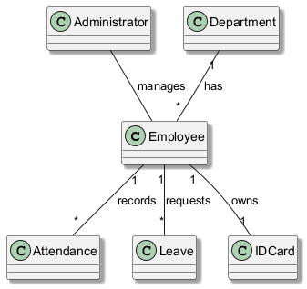

Use Case Model
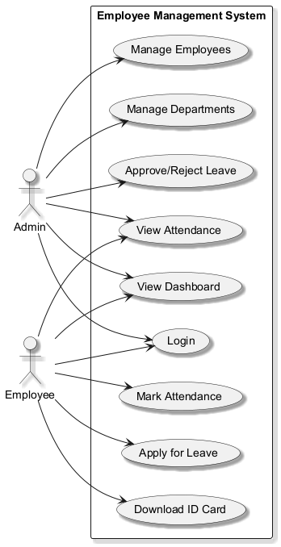

UML Class Diagram
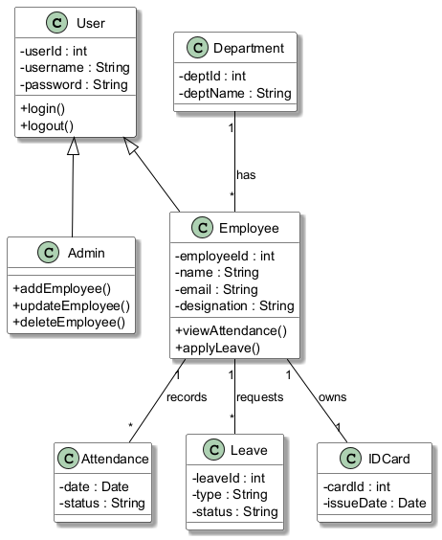

State Transition Diagram
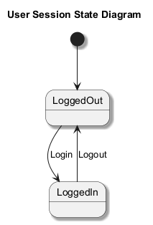

Appendices
Appendix A: Glossary
Refer to Section 1.3
Appendix B: Future Enhancements
- Biometric attendance integration
- Payroll management module
- Mobile application support

Conclusion
This SRS document comprehensively defines the requirements of the Java-based Employee Management System deployed using Jenkins CI/CD. It serves as a foundation for development, testing, deployment, and academic evaluation in compliance with IEEE 29148 standards.

Chapter 2: Code Generation Methodology
2.1 Tool and Method Used
To bridge the gap between system design and implementation, we utilized Visual Paradigm for automated code generation. This process, known as Forward Engineering, allowed us to instantly convert our UML Class Diagrams into working Java skeleton code.
- CASE Tool: Visual Paradigm (Community/Professional Edition)
- Method: Forward Engineering (Instant Code Generation)
2.2 Code Generation Process
The generation process involved the following steps within the Visual Paradigm environment:
- UML Modeling: We finalized the Class Diagram, defining all attributes (including data types like int, String) and operations (methods) for entities such as Employee and Admin.
- Configuration: We selected the "Tools" menu, navigated to Code Engineering, and selected Java as the target language.
- Generation: The tool parsed the visual model and automatically created .java files, handling the syntax, package declarations (com.ems.model), and encapsulation (Getters/Setters) automatically.
2.3 Generated Code
Source code is generated by Visual Paradigm.
2.4 Integration with IDE
Once the code was generated by Visual Paradigm, the files were exported and imported into NetBeans IDE. This allowed us to proceed with the implementation phase, where we added the core business logic inside the generated method stubs.

Chapter 3: Project Implementation Details
3.1 Technology Stack
The application was built using a robust Java-based stack to ensure scalability and reliability.
- Backend: Java EE (Servlets), JDBC for database connectivity.
- Frontend: JSP (JavaServer Pages), HTML5, CSS3.
- Database: MySQL Server.
- Build Tool: Ant/Maven.
- DevOps Tools: Jenkins (CI Server), Ngrok (Tunneling), Apache Tomcat 9/10 (Web Server).
3.2 Implementation Logic
The system follows the Model-View-Controller (MVC) architectural pattern:
- Model: Java POJO classes representing database entities.
- View: .jsp files responsible for the presentation layer (UI).
- Controller: Java Servlets that handle HTTP requests, process business logic, and route data to the views.

Chapter 4: Build and Testing Strategy
4.1 Build Automation
The project build lifecycle is managed via the NetBeans build script, which compiles source files and packages the application into a Web Archive (.war) file suitable for deployment.
4.2 Unit Testing Framework
Unit testing was conducted using the JUnit framework to validate individual components. Critical modules, such as the Authentication logic, were tested for both valid and invalid inputs.
Test Case Example: Admin Authentication
- Objective: Verify that valid credentials grant access while invalid ones deny it.
- Status: PASSED 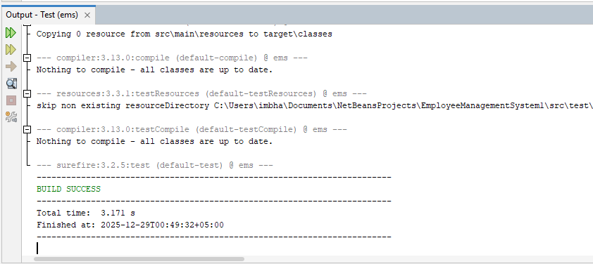

Chapter 5: CI/CD Pipeline Configuration
5.1 Version Control Integration
The project source code is hosted on GitHub to facilitate collaboration and version tracking. The instructor (sharifali.aulecturer@gmail.com ,eshayt7@gmail.com, 233138@students.au.edu.pk) has been added as a contributor.

- Repository URL: https://github.com/rimshaejaz123/EMS_Final
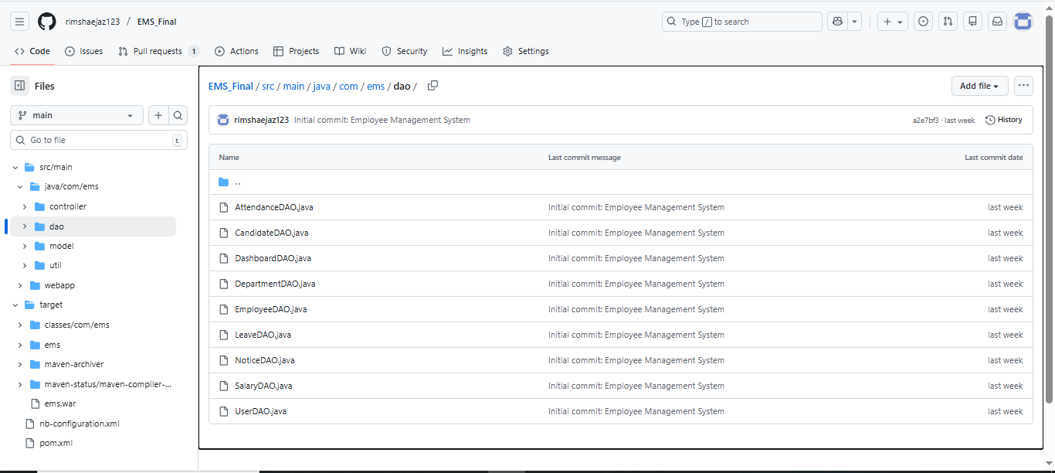
5.2 Continuous Integration (CI) with Jenkins
A CI pipeline was configured on a local Jenkins server (Port 9090) to automate the build process.
Key Configuration Steps:
- SCM Polling: Jenkins is integrated with GitHub using Webhooks.
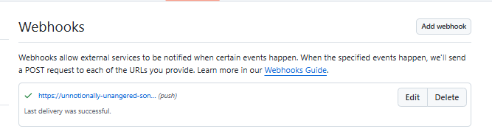
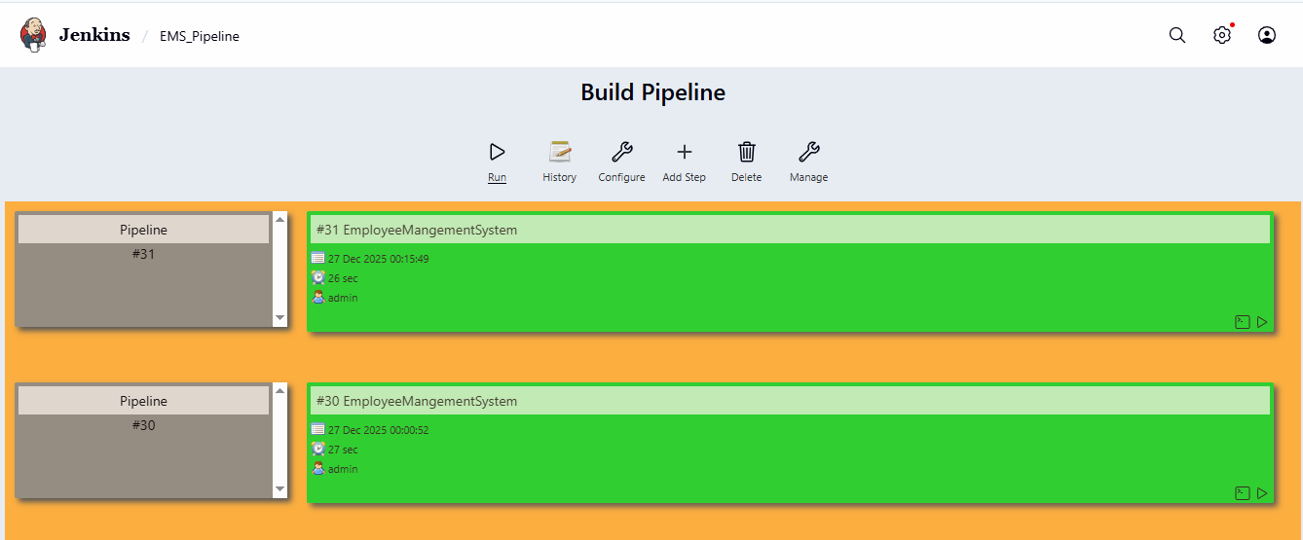
- Ngrok Tunneling: Since Jenkins is hosted locally, Ngrok was used to expose the local server to the public internet, allowing GitHub to send "Push" notifications via the webhook

- Build Trigger: The pipeline automatically triggers whenever a git push command is executed.
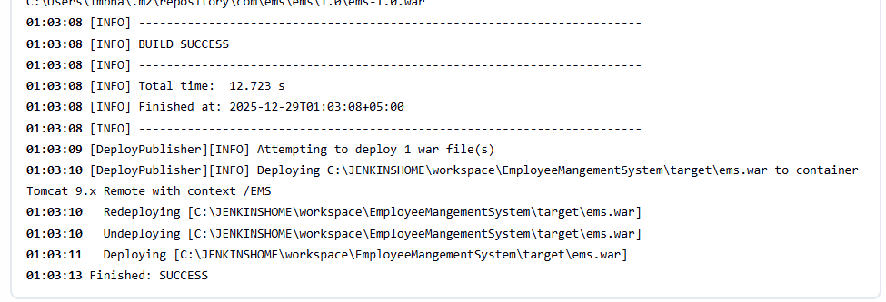
Chapter 6: Application Release and Deployment
6.1 Automated Deployment Strategy
Continuous Deployment (CD) was achieved using the "Deploy to Container" plugin in Jenkins. Upon a successful build, the generated .war artifact is automatically deployed to the Apache Tomcat server running on Port 8080. 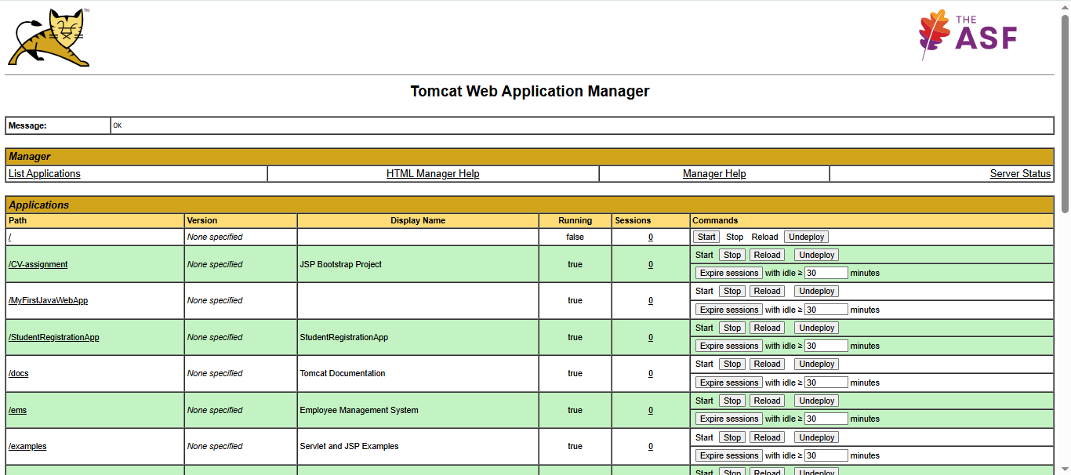
6.2 Deployment Verification
To verify the successful release, the application was accessed via the Tomcat Manager and a web browser.
Tomcat Configuration:
- User Role: A manager-script role was configured in tomcat-users.xml to authorize Jenkins for remote deployment.
- Context Path: The application is deployed at /EMS.
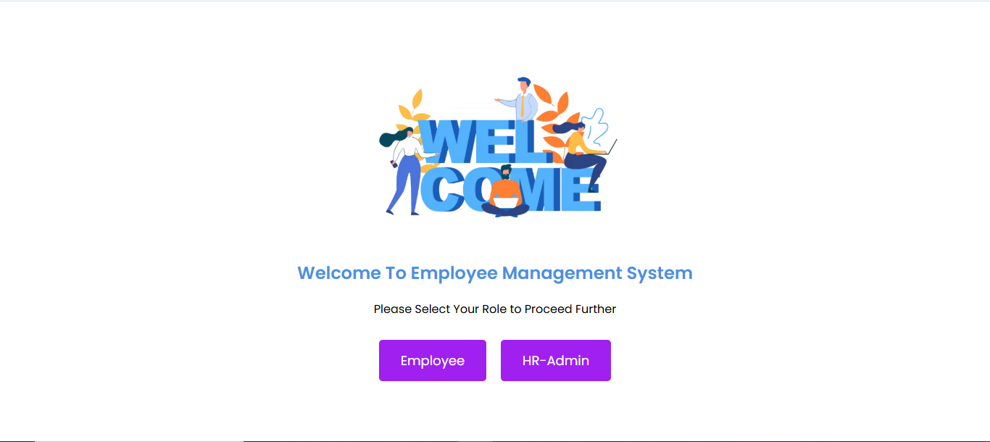

Conclusion
The Employee Management System was successfully designed, implemented, and deployed. The project demonstrates the practical application of Software Engineering principles, from formal UML modeling to modern DevOps practices. The integration of Jenkins and GitHub has established a reliable automated pipeline, ensuring that all code changes are built, tested, and deployed efficiently.

THE END

